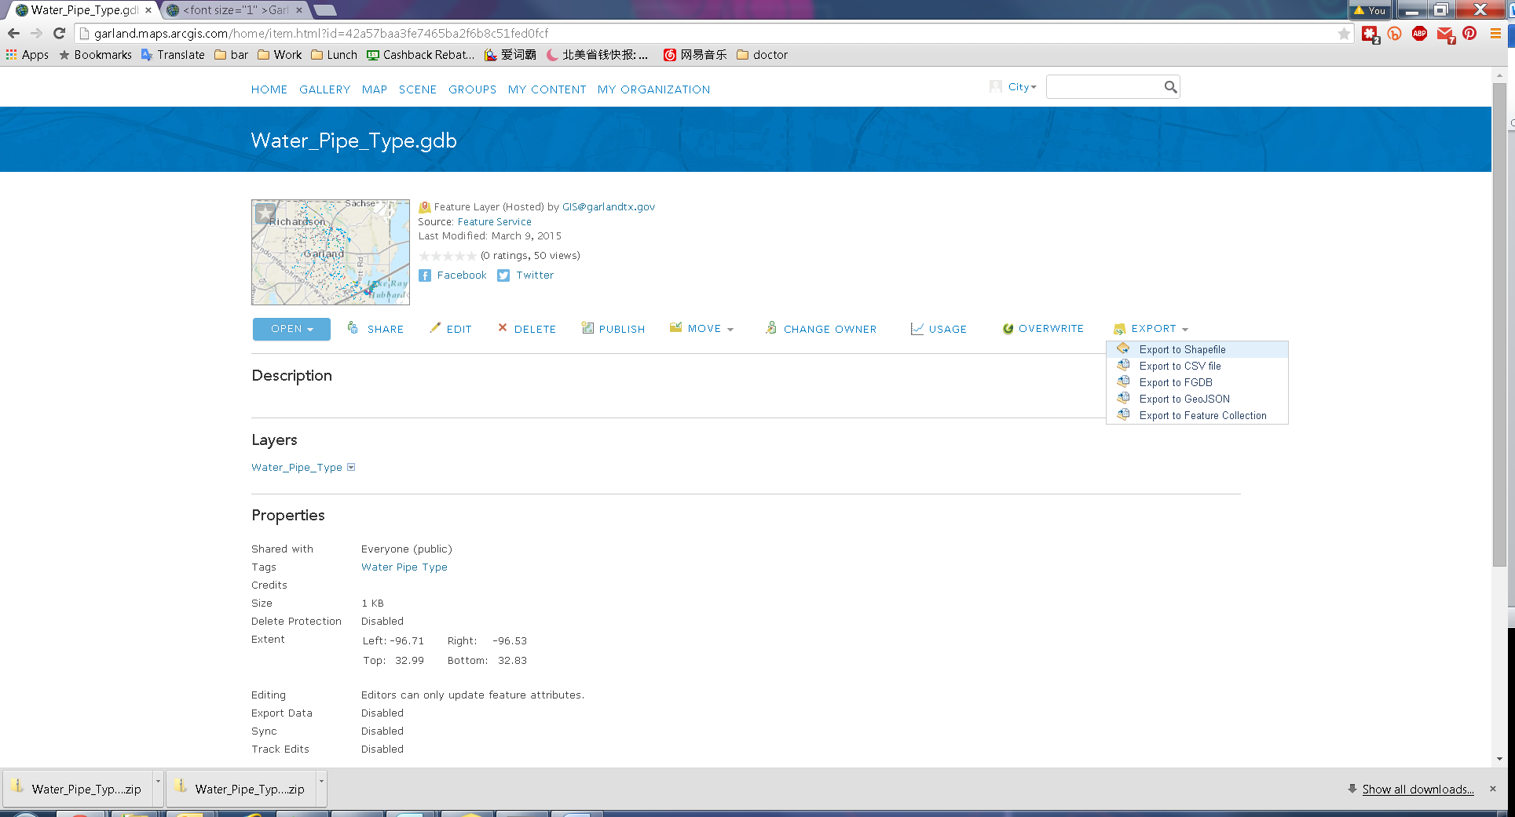

Then Download to local PC. The file will has all the updates.